Rentals

# ERD for UX process

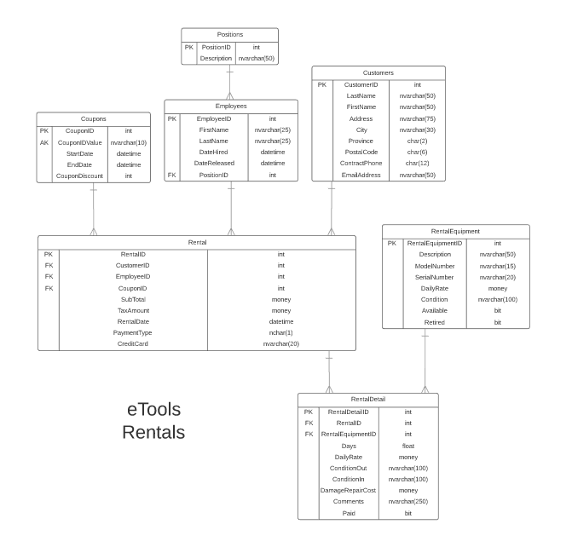

# Possible UX Interface

Rental

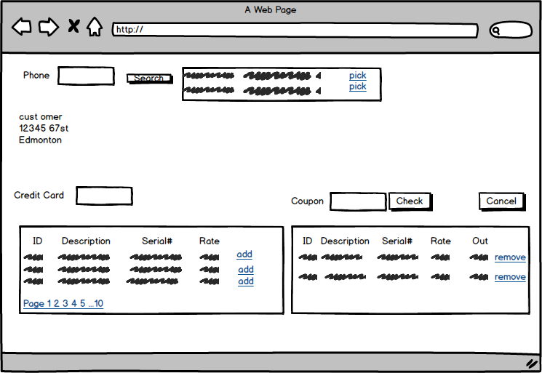

Return Rental

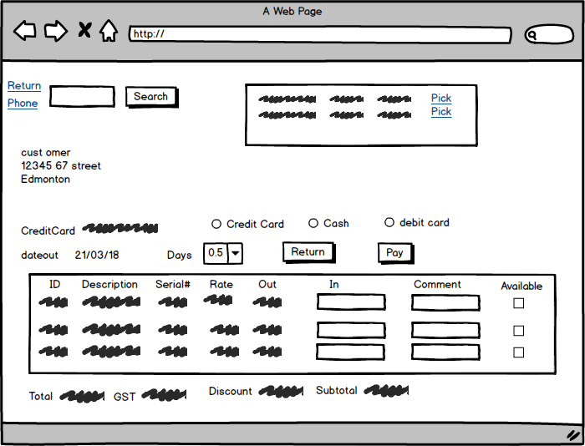

|  |  |  |
| --- | --- | --- |
| **Controls** | | **Events** |
| Search(Customer(ListView))  phonenumber(TextBox) | | Search OnClick   * Validate Data Present * Call BLL * Bind Returned Data to ListView |
| **BBL Class(es) and Method (s)** | | |
| CustomerController | List<customerinfo> List_CustomerByPhone(string phonenumber)   * Retrieve a List of Customers based on the phonenumber. * Return firstname + “,” + lastname, address and pick link button in a listview display in customerinfo List View | |
| **SQL Table(s): (C,R,U,D)** | | **Entities/DTOs/POCOs** |
| Customer(R) | | Customerinfo(P) |

|  |  |  |
| --- | --- | --- |
| **Controls** | | **Events** |
| Customers: pick link button, customer(ListView) | | OnCommand   * Collect Customer info * Display Customer info |
| **BBL Class(es) and Method (s)** | | |
| CustomerController | Customer_Get (int customerid)  -Return customer firstname + “ ,” + lastname, address, City | |
| **SQL Table(s): (C,R,U,D)** | | **Entities/DTOs/POCOs** |
| Customer(R) | | CustomerInfo(P) |

|  |  |  |
| --- | --- | --- |
| **Controls** | | **Events** |
| AvailableRentalEquipment(ListView) | | None/Wired via Object Data Source |
| **BBL Class(es) and Method (s)** | | |
| RentalEquipmentController | List<RentalEquipment> RentalEquipment_Available  -Retrieve a list of available equipment that can be rented, will populate listview.  Display rentalequipmentID, Description, Serialnumber, dailyrate | |
| **SQL Table(s): (C,R,U,D)** | | **Entities/DTOs/POCOs** |
| RentalEquipment(R) | | AvailableEquipment(P) |

|  |  |  |
| --- | --- | --- |
| **Controls** | | **Events** |
| Add: link button, rental(ListView), AvailableRentalEquipment(ListView),  creditCard(TextBox) | | On Command   * Check creditcard TextBox for validation * Send to BLL to add to rental * Change flag in available to false |
| **BBL Class(es) and Method (s)** | | |
| RentalDetailController | Void Add_RentalDetailToRental(int rentalid, int Employeeid, int rentalequipmentid)  TRX(Create Rental if needed, create rental detail , update rental equipments availability) | |
| **SQL Table(s): (C,R,U,D)** | | **Entities/DTOs/POCOs** |
| Rental(C OPT), RentalDetails(C), rentalEquipment(U) | | Rental(E), RentalDescription(E), RentalEquipment(E) |

|  |  |  |
| --- | --- | --- |
| **Controls** | | **Events** |
| Check, coupon(TextBox) | | Check OnClick   * Validate Coupon info from textbox * Send to BLL to add CouponId to rental |
| **BBL Class(es) and Method (s)** | | |
| RentalController | Coupon_GET(string couponidvalue, int rentalid)  TRX(Attach couponcode to rental) | |
| **SQL Table(s): (C,R,U,D)** | | **Entities/DTOs/POCOs** |
| Coupons(R), Rentals(U) | | Coupon(E), Rental(E) |

|  |  |  |
| --- | --- | --- |
| **Controls** | | **Events** |
| Cancel, AvailableRentalEquipment(ListView), rental(ListView) | | Cancel_OnClick   * Collect rentalID, RentalDetailsID, RentalEquipmentID and validate? * Send to BLL to remove from order details * Flag equipment as available for each loop * Check to see if there are no more details on order * Remove order * Refresh screen |
| **BBL Class(es) and Method (s)** | | |
| RentalDetailController | Void Remove_RentalDetailsFromRental(int rentalid, int employeeid, List<RentalEquipmentDetails>RentalItems)  TRX(get rentaldetails, remove rental details, flag rentailequipment as available, check if rental has no details, remove rental) | |
| **SQL Table(s): (C,R,U,D)** | | **Entities/DTOs/POCOs** |
| Rental(D), RentalDetail(D), RentalEquipment(U) | | Rental(E), RentalEquipmentDetails(P) |

|  |  |  |
| --- | --- | --- |
| **Controls** | | **Events** |
| Remove: link button, rental(ListView), AvailableRentalEquipment(ListView) | | On command   * Collect RentalDescriptionId, RentalEquipmentID and RentalID * Send to BLL for removing Rental Equipment from Rental * Refresh order |
| **BBL Class(es) and Method (s)** | | |
| RentalDetailController | Void_RemoveRentalDetailFromRental(int rentalId, int employeeid, int rentalequipmentid, int rentalDetailid)  TRX(find rentaldetailid then remove it, update rentalidequipment as available) | |
| **SQL Table(s): (C,R,U,D)** | | **Entities/DTOs/POCOs** |
| Rentaldetails(U, D), RentalEquipment(U) | | RentalDetail(E) |

|  |  |  |
| --- | --- | --- |
| **Controls** | | **Events** |
| Rental: link button, rentalinfo(textbox),  Returnrental(ListView) | | OnCommand   * Validate RentalID * Call BLL * Bind returned Data to Rental |
| **BBL Class(es) and Method (s)** | | |
| RentalDetailController | List<CustomerRentalDetails> List_DetailsForRental(int rentalid)  Get_CustomerInformation(int CustomerID)  Retrieve a List of rental details and customer information for supplied RentalID. Return (RentalID, RentalDate, CreditCard, CustomerID, CouponID, RentalDetailID, RentalEquipmentID, Description, DailyRate, SerialNumber, Condition out, Condition in, Comments)  Retrieve customer Information as well(combination of last name then first name, address and City) | |
| **SQL Table(s): (C,R,U,D)** | | **Entities/DTOs/POCOs** |
| Customer(R), Rental(R), RentalDetails(R), RentalEquipment(R), Coupon(R) | | CustomerRentalDetails(P) , Customerinfo(P) |

|  |  |  |
| --- | --- | --- |
| **Controls** | | **Events** |
| Phone: link button, rentalinfo(TextBox), Customer(ListView) | | Search OnClick   * Validate Data Present * Call BLL   Bind Returned Data to ListView |
| **BBL Class(es) and Method (s)** | | |
| RentalController | List< CustomerRentalInfo > List_CustomerByPhone(string phonenumber)   * Retrieve a List of Customers based on the phonenumber. * Return firstname + “,” + lastname, address and pick link button in a listview | |
| **SQL Table(s): (C,R,U,D)** | | **Entities/DTOs/POCOs** |
| Customers(R), Rental(R) | | CustomerRentalInfo(P) |

|  |  |  |
| --- | --- | --- |
| **Controls** | | **Events** |
| Customers: pick link button, customer(ListView),  Returnrental(ListView) | | OnCommand   * Validate RentalID * Call BLL   Bind returned Data to Rental |
| **BBL Class(es) and Method (s)** | | |
| RentalDetailController | List<CustomerRentalDetails> List_DetailsForRental(int rentalid)  Get_CustomerInformation(int CustomerID)  Retrieve a List of rental details and customer information for supplied RentalID. Return (RentalID, RentalDate, CreditCard, CustomerID, CouponID, RentalDetailID, RentalEquipmentID, Description, DailyRate, SerialNumber, Condition out, Condition in, Comments)  Retrieve customer Information as well(combination of last name then first name, address and City) | |
| **SQL Table(s): (C,R,U,D)** | | **Entities/DTOs/POCOs** |
| Customer(R), Rental(R), RentalDetails(R), RentalEquipment(R), Coupon(R) | | CustomerRentalDetails(P) , Customerinfo(P), Rental(E) |

|  |  |  |
| --- | --- | --- |
| **Controls** | | **Events** |
| Pay, paymentmethod(CheckList), days(TextBox) | | Pay OnClock   * Validate * Calculate subtotal, gst, Total from discount and days of rental * Refresh screen to show the values * Take in payment method as well as subtotal and gst. |
| **BBL Class(es) and Method (s)** | | |
| RentalController | void update_Rental(int rentaldetailid, int employeeid, double subtotal, char paymenttype, int couponid)  TRX(Updates paymenttype , subtotal and taxamount(GST) based on my coupon discount as well as the days of rental) | |
| **SQL Table(s): (C,R,U,D)** | | **Entities/DTOs/POCOs** |
| Rental(U) | | Payrental(P) |

|  |  |  |
| --- | --- | --- |
| **Controls** | | **Events** |
| Return, Returnrental(ListView) | | Return OnClick  -validate order exists  - Send to BLL to update Rental, RentalDetails and Rental Equipment  - refresh screen |
| **BBL Class(es) and Method (s)** | | |
| RentalDetailController | void Update_RentalDetails( int rentalId, int rentalequipmentid, int rentaldetailid)  TRX(Find rentalequipment, update with new information, make equipment available, if everything is in good condition remove credit card) | |
| **SQL Table(s): (C,R,U,D)** | | **Entities/DTOs/POCOs** |
| RentalEquipment(U), RentalDetails(U) | | CustomerRentalDetails(P) |

Comments

You seem to hand a good handle on what to do.